Software Requirement Specifications
AI-Based Personalized Feedback System Using Explainable Machine Learning by python



Submitted by
Muhammad Abdullah (F22BINFT1M01185)

Submitted to
Dr. Mustafa Hameed

Department of Information Technology Faculty of Computing

The Islamia University of Bahawalpur

Meeting Details

Sr No | Details | Date | Supervisor  Signature

Summary

This project is an AI-Based Personalized Feedback System built using Python and focusing on Explainable Machine Learning (XAI). The system's main goal is to give users personalized advice and, crucially, a clear reason why that advice was given, avoiding the "black-box" issue of standard AI. It works by first ingesting a user's data (like test scores or activity logs) and using a machine learning model to predict their performance or risk. Then, the XAI engine (using tools like SHAP or LIME) calculates and generates a simple explanation showing which factors most influenced the prediction. The system combines this transparent explanation with actionable feedback and presents it to the user via a dashboard. This approach ensures the feedback is not only effective and timely but also trustworthy, meeting non-functional requirements for transparency and performance.

Table of Contents

Introduction
  - 1.1 Purpose
  - 1.2 Scope
  - 1.3 Product Perspective
  - 1.4 User Characteristics
  - 1.5 Similar Apps and Systems/Literature Review
  - 1.6 Proposed Technologies

Requirements
  - 2.1 Functional Requirements
    - 2.1.1 User Data Ingestion
    - 2.1.2 Performance Prediction
    - 2.1.3 Feedback Generation
    - 2.1.4 Explanation Generation (XAI)
    - 2.1.5 Feedback Display
    - 2.1.6 Model Retraining
  - 2.2 Non-Functional Requirements
    - 2.2.1 Transparency
    - 2.2.2 Response Time
    - 2.2.3 Data Privacy
    - 2.2.4 Accuracy
    - 2.2.5 User Load

Use Cases and Flow of Processes
  - System Level Use Case Diagram
  - Detailed Use Case Specification (Use Case 1, Use Case 2, etc.)
- Diagram
- References

Introduction

This SRS document specifies the requirements for a Network Intrusion Detection and Traffic Analysis System developed using Python. The system aims to monitor network traffic, detect intrusions, analyze patterns, and provide actionable insights to enhance security for small to medium-sized networks.

Purpose
The primary purpose is to automate the delivery of personalized, high-quality feedback while eliminating the opacity of standard AI models. The system aims to:
- Predict a user's performance or status (e.g., risk of failure, skill gaps).
- Generate a tailored, actionable feedback message (the "what").
- Provide a clear, transparent explanation for the prediction or feedback (the "why") using XAI.

Scope

The system will encompass:
- A data ingestion module for processing user interaction data (e.g., assignments, quizzes, usage logs).
- A Machine Learning (ML) core for prediction and analysis.
- An XAI engine to generate model explanations.
- A user interface (e.g., a web-based dashboard) for viewing personalized feedback and its associated explanations.
- The system will focus on a specific domain (e.g., an educational platform, a health/fitness application, or a coding review tool). For this SRS, we will assume an educational context (student assessment).

Product Perspective
The AI-Based Personalized Feedback System is intended to be a standalone application that can integrate seamlessly with existing platforms, such as a Learning Management System (LMS) via APIs. It serves as a critical analytical layer, taking raw user data as input and providing actionable, explained feedback as output.

User Characteristics

User Role | Description | Key Interaction
Learner/Student (End User) | Individuals receiving feedback. They require clear, concise, and trustworthy explanations of their performance to improve self-regulation. | Submitting work, viewing personalized feedback, reading XAI explanations.
Instructor/Administrator | Individuals who manage the system, monitor user trends, and potentially fine-tune the feedback parameters. | Viewing aggregate performance metrics, monitoring model health (e.g., drift, fairness), and managing user accounts.

Similar Apps and Systems/Literature Review

The following systems and studies provide context:

- Adaptive Learning Platforms: These systems use AI to continuously track a user's performance and knowledge gaps, dynamically adjusting the content or learning path to optimize the educational experience.
- Recommendation Systems: Often used in MOOCs, these systems group similar users (learners) to suggest relevant assignments, videos, or course materials, though they typically don't explain the logic behind the suggestion.
- LLM-Based Feedback Tools: Tools powered by large language models (like GPT) that excel at generating high-quality, human-like, and highly personalized text feedback on complex assignments.
- Black-Box AI: This refers to complex machine learning models (like deep neural networks) whose predictions are accurate but whose internal decision-making process is opaque and cannot be easily understood by human

Proposed Technologies

The system will be implemented using the Python language.

Component | Proposed Technology | Justification
Machine Learning (Prediction) | Scikit-learn (basic ML) or TensorFlow/PyTorch (Deep Learning - RNN/LSTM for sequence data) | Python libraries for building predictive models (e.g., predicting student grade or risk).
Explainable AI (XAI) | SHAP (SHapley Additive exPlanations) or LIME (Local Interpretable Model-Agnostic Explanations) | Provides model-agnostic methods to explain individual predictions ("why the model made this specific decision").
Data Processing/NLP | Pandas, NumPy, NLTK/SpaCy | Essential Python libraries for data cleaning, analysis, and processing text-based inputs/generating text feedback.
Web Framework (Dashboard/API) | Django or Flask | Python frameworks for building the user-facing web dashboard and the API for external system integration.

Requirements

Functional Requirements

    - User Data Ingestion

Description: The system must be able to securely receive and process raw user interaction data. This includes quantitative data (like assignment scores, completion rates, or usage frequency) and qualitative data (like text submissions). Why it's Needed: This is the system's entry point; the ML model cannot make predictions without the necessary, well-structured input data.

    - Performance Prediction

Description: The core machine learning component must execute a trained model to analyze the ingested data and output a prediction about the user. This prediction could be a future score, a risk level (e.g., "high-risk student"), or a classification (e.g., "needs help with Topic A"). Why it's Needed: This prediction forms the basis of the personalized feedback; it determines what advice the user needs.

    - Feedback Generation

Description: The system must take the prediction (FR002) and the explanation (FR004) and synthesize a clear, actionable textual message for the user. This feedback should be customized, addressing the user's specific performance areas. Why it's Needed: The final output must be in a format that the user can easily understand and act upon to improve their behavior or performance.

    - Explanation Generation (XAI)

Description: This requirement mandates the use of an Explainable AI (XAI) engine (e.g., LIME or SHAP) to generate a transparent explanation for the prediction made in FR002. It identifies which specific input features (e.g., low quiz grades, short reading time) were the most influential factors. Why it's Needed: This is the defining feature of your project; it builds user trust and helps the user understand why they received the prediction and feedback.

    - Feedback Display

Description: The system must present the combined personalized feedback (FR003) and its XAI explanation (FR004) clearly through a user-friendly interface, typically a web dashboard. Why it's Needed: The generated output is useless unless it is effectively and accessibly communicated to the end user.

    - Model Retraining

Description: The system must provide a mechanism (e.g., an administrator interface) to periodically retrain the machine learning model using new, accumulated data. Why it's Needed: ML models degrade over time (known as "model drift") as user behavior or data patterns change; retraining is essential to maintain the system's accuracy and relevance.

Non-Functional Requirements

Category | ID | Requirement Name | Brief Explanation
Explainability/Trust | NFR001 | Transparency | This is the most critical NFR, requiring the system to be open and honest about how it reached a decision. It ensures users get the justification (the "why") behind the feedback, which builds trust in the AI.
Performance | NFR002 | Response Time | The system must be fast, delivering the personalized and explained feedback to the user in a matter of seconds. Slow response times would make the feedback irrelevant or delay the user's ability to act on the advice.
Security/Ethics | NFR003 | Data Privacy | The system must strictly secure and anonymize all user data. Since the system handles sensitive personal information (like performance and learning struggles), privacy is legally and ethically essential.
Reliability/Quality | NFR004 | Accuracy | The underlying predictive Machine Learning model must consistently produce correct predictions, hitting a defined minimum success rate (e.g., 85%). If the model is not accurate, the feedback will be useless or misleading.
Operational | NFR005 | Scalability | The system must be designed to handle growth, meaning it can support an increasing number of users and process larger datasets without experiencing a significant drop in performance or speed.
Use Cases and Flow of Processes

System Level Use Case Diagram

This is a high-level, visual map that shows the relationship between your main users (called Actors) and the primary functions of your system (the Use Cases).
- Actors: For your system, the main actors would be the Learner/Student (the end-user receiving feedback) and the Administrator/Instructor (the one managing the system and model).
- Use Cases: These are high-level functions, such as "Receive Explained Feedback," "Submit Activity," "Monitor Model Performance," and "Retrain ML Model."

Detailed Use Case Specification (Use Case 1, Use Case 2, etc.)

Each major function identified in the diagram is then described in a formal, structured
table. This table specifies the exact steps the system and the actor must take to
complete the process successfully.
The most critical use case for your project is Receive Personalized and Explained
Feedback.

Category | ID | Requirement Name | Brief Explanation
Explainability/Trust | NFR001 | Transparency | This is the most critical NFR, requiring the system to be open and honest about how it reached a decision. It ensures users get the justification (the "why") behind the feedback, which builds trust in the AI.
Performance | NFR002 | Response Time | The system must be fast, delivering the personalized and explained feedback to the user in a matter of seconds. Slow response times would make the feedback irrelevant or delay the user's ability to act on the advice.
Security/Ethics | NFR003 | Data Privacy | The system must strictly secure and anonymize all user data. Since the system handles sensitive personal information (like performance and learning struggles), privacy is legally and ethically essential.
Reliability/Quality | NFR004 | Accuracy | The underlying predictive Machine Learning model must consistently produce correct predictions, hitting a defined minimum success rate (e.g., 85%). If the model is not accurate, the feedback will be useless or misleading.
Operational | NFR005 | Scalability | The system must be designed to handle growth, meaning it can support an increasing number of users and process larger datasets without experiencing a significant drop in performance or speed.

Diagrams

1. System Level Use Case Diagram (Figure 1)
This diagram provides a high-level view of the actors (Learner and Administrator) and the primary functions of your entire system.
Diagram Query/Tag | Description
**** | Shows the Learner interacting with "Receive Explained Feedback" and "View History," and the Administrator interacting with "Monitor Model Performance" and "Trigger Model Retraining."
2. Activity Diagram (for UC001: Get Explained Feedback)
This diagram illustrates the step-by-step sequential and conditional flow of the most critical process: generating explained feedback.
Diagram Query/Tag | Description
**** | Visualizes the process starting with Data Submission $\rightarrow$ Prediction $\rightarrow$ Decision Node (Low Confidence?) $\rightarrow$ XAI Calculation $\rightarrow$ Feedback Synthesis $\rightarrow$ Display Output.
3. Sequence Diagram (for UC001: Get Explained Feedback)
This diagram shows the time-ordered interactions and messages passed between the different components (objects) of your system to generate the feedback.
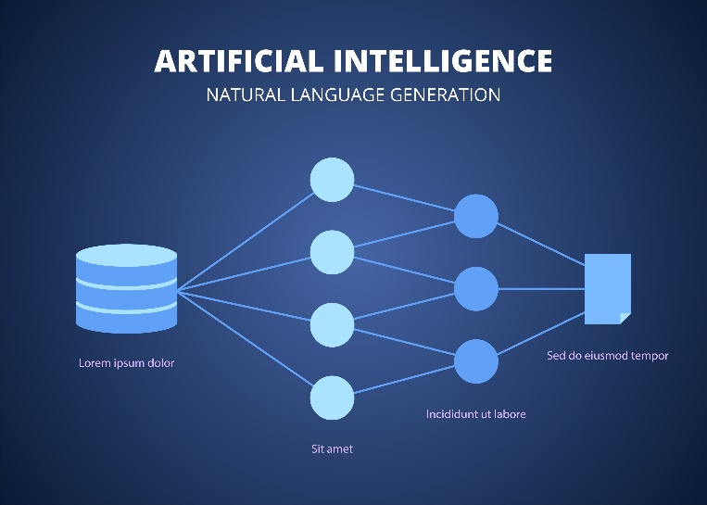

5.References

- [1] What is Explainable AI (XAI)?https://www.ibm.com/think/topics/explainable-ai
- [2] A Beginner's Guide to Explainable AI and Its Role in Building Trust in AI Systemshttps://www.coursera.org/articles/explainable-ai
- [3] A Guide to Explainable AI Using Pythonhttps://thepythoncode.com/article/explainable-ai-model-python
- [4] Explainable AI for Data-Driven Feedback and Intelligent Action Recommendations to Support Students Self- Regulationhttps://www.frontiersin.org/journals/artificial-intelligence/articles/10.3389/frai.2021.723447/full
- [5] Adaptive Learning Using Artificial Intelligence in e-Learning: A Literature Reviewhttps://www.mdpi.com/2227-7102/13/12/1216
- [6]Explainable AI for Data-Driven Feedback and Intelligent Action Recommendations to Support Student Self-Regulationhttps://www.diva-portal.org/smash/get/diva2:1889043/FULLTEXT01.pdf
- [7]Personalized and Timely Feedback in Online Education: Enhancing Learning with Deep Learning and Large Language Modelshttps://www.mdpi.com/2414-4088/9/5/45
- [8]AI-Based Student Feedbackhttps://www.flowhunt.io/glossary/ai-based-student-feedback/
- [9]Personalised Feedback Framework for Online Education Programmes Using Generative AIhttps://arxiv.org/pdf/2410.11904
- [10]Python-Based Personalized Recommendation System Developmenthttps://www.scribd.com/document/851210173/python-based-Personalized-Recommendation-System-Development

